**Open Source International Soil Water Toolbox With New Data collected by MWLR and Plant & Food**

J.A.P. Pollacco1, J. Fernández-Gálvez1,2 *, L. Lassabatere3, Simone Di Prima4, Wei Hue5, R. Angulo-Jaramillo3, Stephen McNeill1, S. Carrick1, Anne Verhoef6, Nina Koele1, Gwen Grelet1, Duane Peltzer1

1 Manaaki Whenua – Landcare Research, Lincoln 7640, **New Zealand**

2 University of Granada, Granada 18071, **Spain**

3 Univ Lyon, Université Claude Bernard Lyon 1, CNRS, ENTPE, UMR5023 LEHNA, Vaulx en Velin, Lyon 69518, **France**

4 Università degli Studi di Sassari, Department of Agriculture, **Italy**

5 New Zealand Institute for Plant & Food Research Limited, **New Zealand**

6 University of Reading, **UK**

**Overview of the Open Source International Soil Water Toolbox**

C

haracterization of soil hydraulic properties is crucial to describe the storage and movement of water into the soil. The challenges associated to characterize soil hydraulic properties have led the development of several measuring techniques and modelling approaches which depends on soil type and spatial scale. Nevertheless, the most appropriate techniques are not well understood. The development of an *open source international soil water toolbox* would compile the most relevant tools, enable to validate them and to adapt them to New-Zealand soils dominated by fine texture. It will also enable to derive the uncertainties of different methods in deriving soil water fluxes.

The demand for this toolbox is high (as shown by the list of authors) which ranges from soil scientist, hydrologist and ecologist and has attracted international collaboration worldwide.

It is hoped that this toolbox will facilitate the collection and deriving accurate soil hydraulic parameters which will significantly contribute to improve the way we manage our soil and water now and into the future.

***Key features of the toolbox:***

* Includes a set of software which enables to derive soil hydraulic parameters and soil water fluxes by using different approaches in order to facilitate the comparison and combination of different methods;
* Programmed in Julia language, which is a high-level, high-performance, dynamic programming language and which is easily understood by non-programmers (Bezanson et al., 2017; Perkel, 2019).
* The toolbox architecture is modular which facilitates adding/ modification of modules relatively easy and fast. Different already published models as well as newly developed software are combined. The advantages for combining different tools is that they share common modules so that improving/updating one module would benefit the other linked modules.

***Specific features of the toolbox are:***

* Predict *soil water retention curves* from particle size distribution (PSD) by using classical methods;
* Predict *soil water retention curves* from PSD by using laser method;
* Derive unique set of *hydraulic parameters* for different model (e.g. van Genuchten, Kosugi, Brooks and Corey, …);
* Derive unique set of hydraulic parameters from *infiltration* data when PSD is not available;
* Derive unique set of hydraulic parameters from *infiltration* data when PSD is available;
* Derive residual soil moisture, θr , from PSD
* Determine minimum of time to perform infiltration tests;
* Compute soil sorptivity and soil diffusivity using different approaches;
* Predict 1D time series of: *soil moisture*, *ground water recharge*, *root water uptake* with the derived hydraulic parameters;
* Derive physical feasible range of hydraulic parameters sets by seeing soil hydraulic parameters as linked;
* Estimates of *ponding time*, *soil water holding capacity*, *field capacity, wiling point*, *saturated hydraulic conductivity*, *infiltration rate* (1D and 3D).
* Derive hydraulic properties for soils with single and dual porosity behaviour;
* Plotting PSD into a soil textural triangle;
* Visualisation of the results in graphic and tabulated form;

**Foreseen challenges of SoilWater-Toolbox**

The foreseen challenges which will need to be addressed by the SoilWater-Toolbox for which most of them where highlighted in the previous publication (Fernández-Gálvez et al., 2019; 6. Future work and recommendations to improve BEST).:

* Due to limited measured data points near saturation, laboratory Ks could not be derived and therefore we could not compare *K*s derived from alternative methods with laboratory data;
* *Infiltration* data with high *initial soil moisture* giving limited information in the transit state;
* *Infiltration* data stopped too early giving limited information in the steady state;
* Establish physically based constraints for the derived soil hydraulic parameters so that the soil hydraulic characterization is compatible with the physical laws governing the storage and movement of water in the soil.

In New-Zealand there are some of the most challenging soils texture to derive their hydraulic properties including: *Loamy silt, Sandy loam, Silt loam* and *Silty clay* texture. This is an additional opportunity to contribute to improve our knowledge on:

* **Sorptivity** would require adaptation for silty loam soils;
* The **Quasi-Exact** & **BEST** methods where not yet validated with silty loam soils;
* Derive unique set of hydraulic parameters from *infiltration* data when PSD is available and *initial soil moisture* is high and infiltration rates are slow;
* Deriving unique set of physical hydraulic parameters when only *soil water retention* data is available (e.g. derived from PSD or laboratory);

**Limitation of BEST or QuasiExact method**

The BEST or QuasiExact solution (Fernández-Gálvez et al., 2019) could only derive unique **2** parameters which are *Ks* and *Sorptivity*. It is assumed that θs is derived from bulk density. Therefore, the challenge is to derive a unique 2 others parameters which are the *standard deviation* and the *mean pore size* of the pore size distribution.

Although it is possible to derive the *θ(Ψ)* form PSD data, it is not possible to directly compare the optimal hydraulic parameters derived from laboratory measurements with the hydraulic parameters derived from the PSD model. This limitation arises because equally good combinations of hydraulic parameters could be derived, which are “sets of truly linked parameters” (Pollacco et al., 2008a, 2008b; Pollacco and Angulo-Jaramillo, 2009; Fernández-Gálvez et al., 2019). This is because the PSD model derives the *θ(Ψ)*  but no estimate is provided for *K(θ)*  to act as a constraint for the resolution of non-uniqueness. This issue needs to be the subject of further investigation as it is indicated in some of the latest research.

The same non-unique linear relationship can be found between *Sorptivity* and the 2 others parameters. Therefore, combining 2 linear relationship would hopefully enable to predict a unique set of hydraulic parameters.

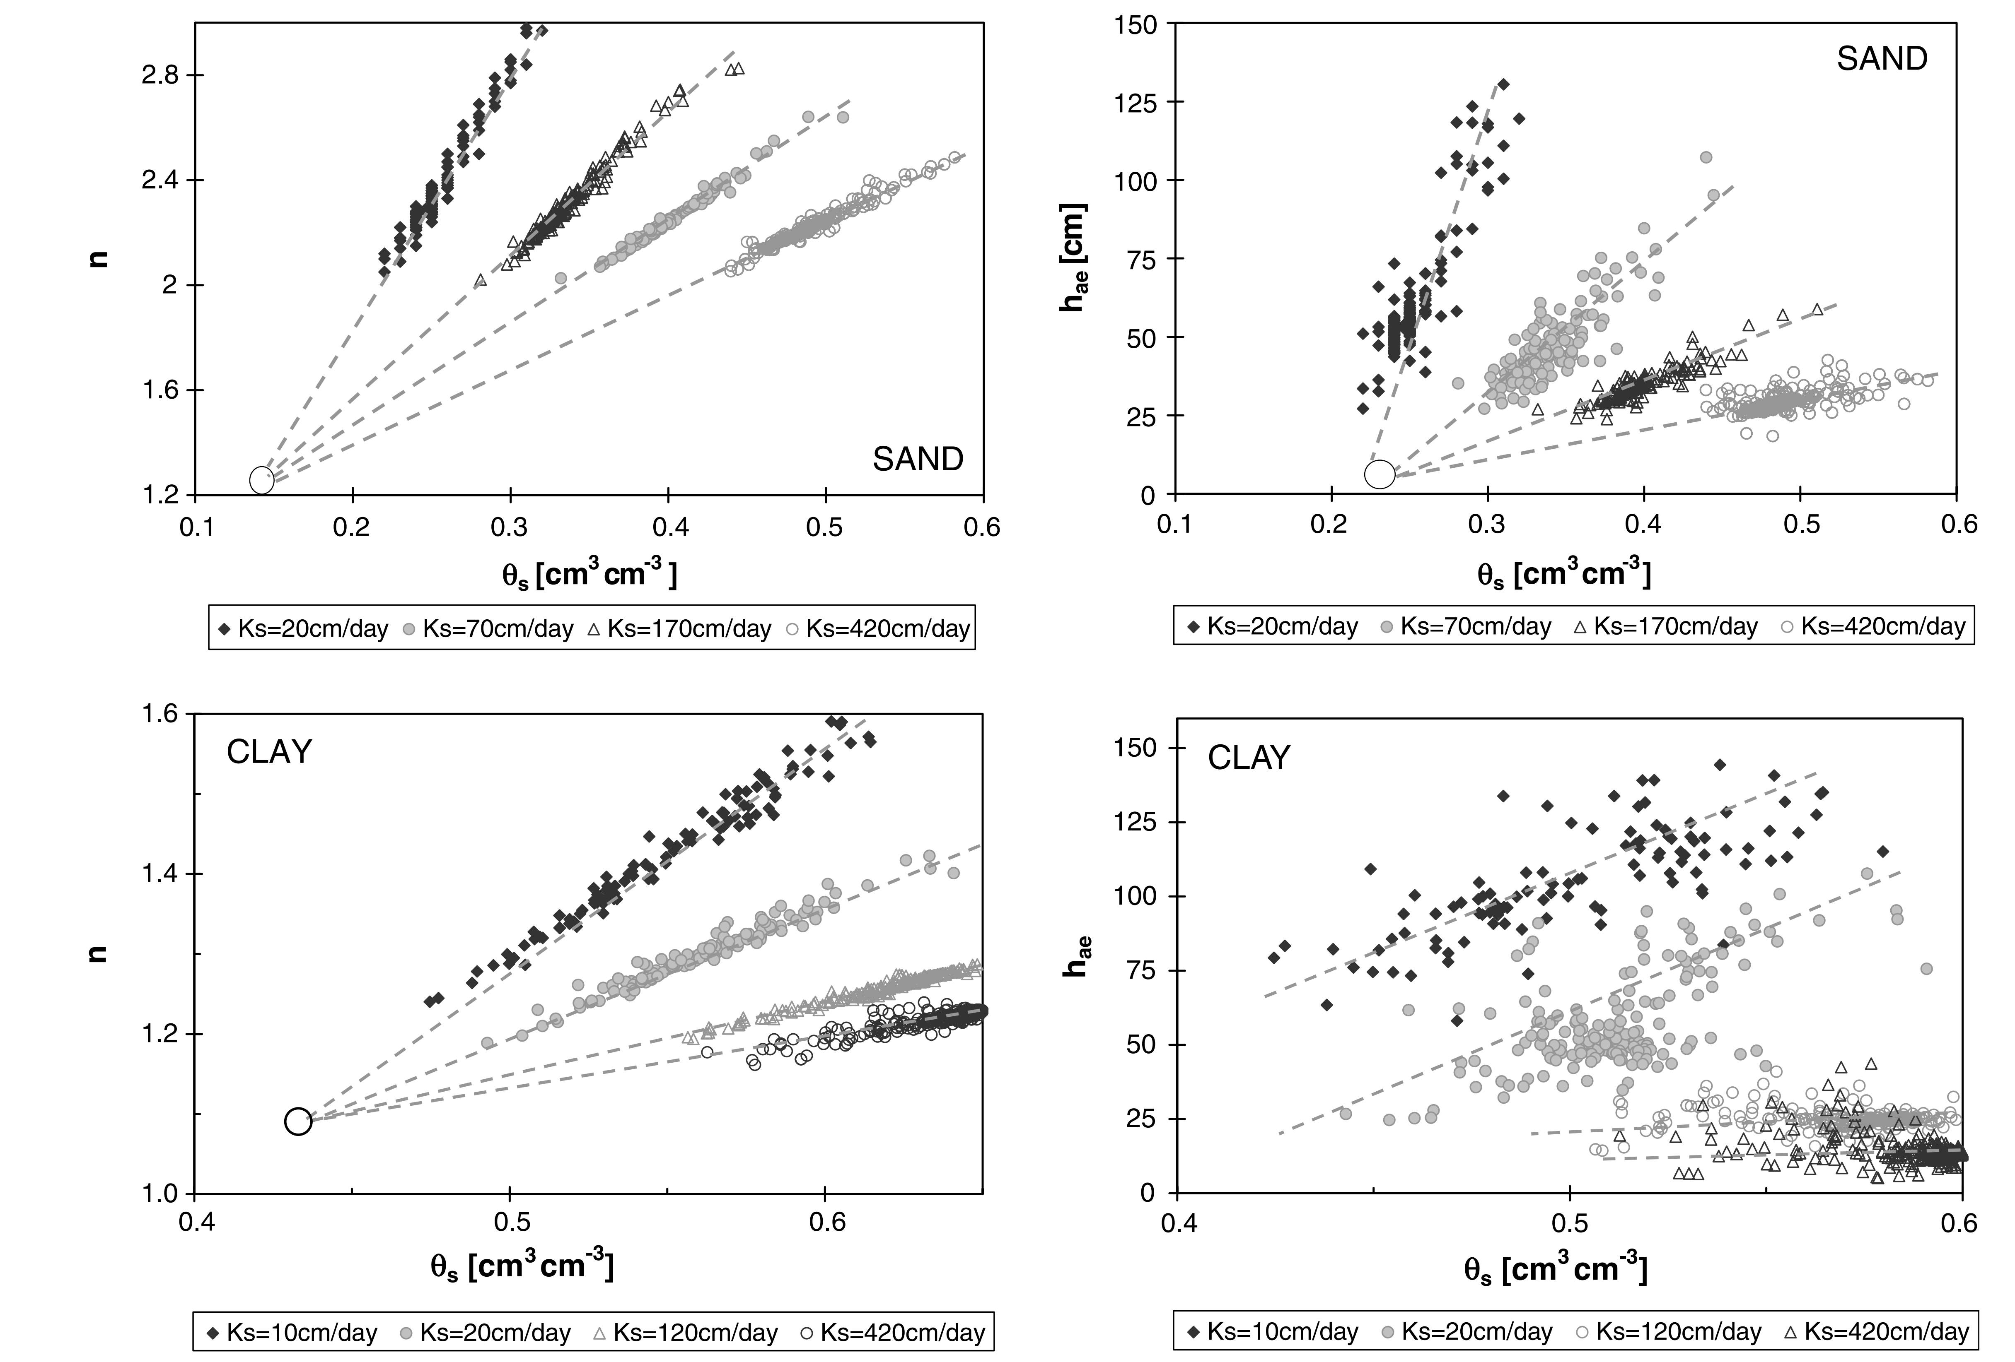

**Figure:** Problem of non-uniquess of optimizing hydraulic parameters of van Genuchten model (Pollacco et al., 2008b)

**Progress of development of SoilWater-Toolbox**

Below are the proposed bare minimum steps to get the SoilWater-Toolbox and framework operational.

|  |  |  |
| --- | --- | --- |
| **Description** | **Status** | **Estimated hours pending** |
| **MODULE: READING** | | |
| Read raw data:   * Psd data if available; * Laboratory *θ(*Ψ*)* data if available; * Laboratory *K(*Ψ*)* data if available; * Infiltration data if available; * Select soil Id; | Mainly done, working such that the other modules can read the data in the universal 3 columns data structure; | **4** |
| Validity of the input data. | The validity of the input data will be performed in the future. | **?** |
| **MODULE: HYDAULIC PARAM** | | |
| Compute θr from PSD by using MODULE Psd or by optimizing θr (Pollacco et al., 2019) | Done | **0** |
| Derive a unique set of hydraulic parameters of unimodal *van Genuchten* or *Kosugi* (bimodal or unimodal) from *θ(Ψ)* and *K(θ)* data. | Done | **0** |
| Could add different *θ(Ψ)* and *K(θ)* models. | This could be performed at a later stage if required | **?** |
| Derive an algorithm to derive a unique set of physical hydraulic parameters since different sets of hydraulic parameters could produce similar θ(Ψ) (Pollacco et al., 2008b). | One can reduce the non-uniqueness by assuming relationship between the mean and standard pore size (Pollacco et al., 2013). | **28** |
| **MODULE: Particle Size Distribution** | |  |
| From PSD data compute θ(Ψ)psd (Pollacco et al., 2019). Than derive the hydraulic parameters from θ(Ψ)psd of the selected model (e.g. *Brooks and Corey, van Genuchten, Kosugi*) by using MODULE HYDAULIC PARAM. | Wiring nearly done.  At this stage no future development is required. | **15** |
| Introduce effect of hydrophobicity. | This may be required for the wilding pine project, where measurements are taken under pines. | **?** |
| **MODULE: KS** | | |
| Compute Ks from θ(Ψ) (Pollacco et al., 2017, 2013) | Require wiring, I need to translate from Python to Julia.  At this stage no future development is required. | **7** |
| **MODULE: Infiltration** | |  |
| **Input:** *time series of cumulative* *infiltration*, *initial soil moisture* and *total porosity*.  **Output:**   * Derive the hydraulic parameters, and infiltration curves for any initial soil moisture. * When no Psd is available than relationship between Kosugi parameters σ and Ψm is assumed (Fernández-Gálvez et al., 2019); | Finalize wiring | **14** |
| Sorptivity adapted for silty clay | Require further international research if the current models fail. | **?35** |
| With Psd data available than we will need combine MODULE: PSD & MODULE INFILTRATION. The methodology needs to be developed. | This is crucial and would require further research. This can be based on the Linking Test (Pollacco et al., 2008a, 2008b; Pollacco and Angulo-Jaramillo, 2009) | **35** |
| Test with alternative published methods:  Slope/ Intercept, etc… | Only required if Plant & Food require. We will start using the Quasi Exact solution which has less assumptions, but slower. | **?20** |
| **MODULE: Texture triangle** | | |
| Draw the texture triangle and classes of the PSD data. (Pollacco et al., 2019) | Require wiring  At this stage we will not show the different classes in the plot. | **4** |
| **MODULE: PHYSICALLY BASED MODEL AND SCALLING** | |  |
| The sensitivity of the derived hydraulic parameters in deriving the water fluxes can be performed by using the developed HyPix model. | In development with NIWA, CNRS France. |  |

**FURTHER FUNDING OPPORTUNITIES****: Science Den**

The Science Den is a new initiative as part of Strategy 22 that aims to:

1. Foster an atmosphere of creativity in MWLR
2. Encourage exploration of innovative ideas and
3. Support turning good ideas into reality.

The scheme is all about the ideas themselves, not running projects or doing the actual research because really innovative research isn't possible without really good ideas in the first place. No ideas are out of scope. Risk-taking is encouraged, and failure will be celebrated alongside success if we learn from it and try again.

Great ideas will be supported to a maximum of $15,000.

Funding can be used for whatever is needed to take the idea forwards, as outlined in the application. For example, it might pay for some time for further reading, making a trip to visit an expert somewhere else, running a pilot field or laboratory experiment, or small workshop, or whatever else will help develop the thinking or develop a proof-of-concept. Any funding must be used by the end of that financial year, as it is SSIF. We have a total of $100,000 available to support great ideas in the 2018/19 financial year and $200,000 in the 2019/20 financial year.

Because great ideas do not happen to order, the Science Den applications will have no deadlines and the selection panel will meet frequently, as needed.

<https://landcareresearch.sharepoint.com/sites/strategy22/SitePages/The-Science-Den.aspx>

**REFERENCES**

Bezanson, J., Edelman, A., Karpinski, S., Shah, V.B., 2017. Julia: A Fresh Approach to Numerical Computing. SIAM Rev. 59, 65–98. https://doi.org/10.1137/141000671

Fernández-Gálvez, J., Pollacco, J.A.P., Lassabatere, L., Angulo-Jaramillo, R., Carrick, S., 2019. A general Beerkan Estimation of Soil Transfer parameters method predicting hydraulic parameters of any unimodal water retention and hydraulic conductivity curves: Application to the Kosugi soil hydraulic model without using particle size distribution data. Advances in Water Resources 129, 118–130. https://doi.org/10.1016/j.advwatres.2019.05.005

Perkel, J.M., 2019. Julia: come for the syntax, stay for the speed. Nature 572, 141–142. https://doi.org/10.1038/d41586-019-02310-3

Pollacco, J.A.P., Angulo-Jaramillo, R., 2009. A Linking Test that investigates the feasibility of inverse modelling: Application to a simple rainfall interception model for Mt. Gambier, southeast South Australia. Hydrological Processes 23, 2023–2032.

Pollacco, J.A.P., Braud, I., Angulo-Jaramillo, R., Saugier, B., 2008a. A Linking Test that establishes if groundwater recharge can be determined by optimising vegetation parameters against soil moisture. Annals of Forest Science 65.

Pollacco, J.A.P., Fernandez-Galvez, J., Carrick, S.T., 2019. Improved prediction of water retention curves for fine texture soils using an intergranular mixing particle size distribution model. Journal of Hydrology.

Pollacco, J.A.P., Nasta, P., Ugalde, J.M.S., Angulo-Jaramillo, R., Lassabatere, L., Mohanty, B.P., Romano, N., 2013. Reduction of feasible parameter space of the inverted soil hydraulic parameters sets for Kosugi model. Soil Science SS-S-12-00268.

Pollacco, J.A.P., Ugalde, J.M.S., Angulo-Jaramillo, R., Braud, I., Saugier, B., 2008b. A Linking Test to reduce the number of hydraulic parameters necessary to simulate groundwater recharge in unsaturated soils. Adv Water Resour 31, 355–369. https://doi.org/10.1016/j.advwatres.2007.09.002

Pollacco, J.A.P., Webb, T., McNeill, S., Hu, W., Carrick, S., Hewitt, A., Lilburne, L., 2017. Saturated hydraulic conductivity model computed from bimodal water retention curves for a range of New Zealand soils. Hydrol. Earth Syst. Sci. 21, 2725–2737. https://doi.org/10.5194/hess-21-2725-2017